TESTIMONY OF

CHARLES D. NOTTINGHAM
CHAIRMAN

SURFACE TRANSPORTATION BOARD
395 E STREET, SW
WASHINGTON, DC 20423
(202) 245-0200

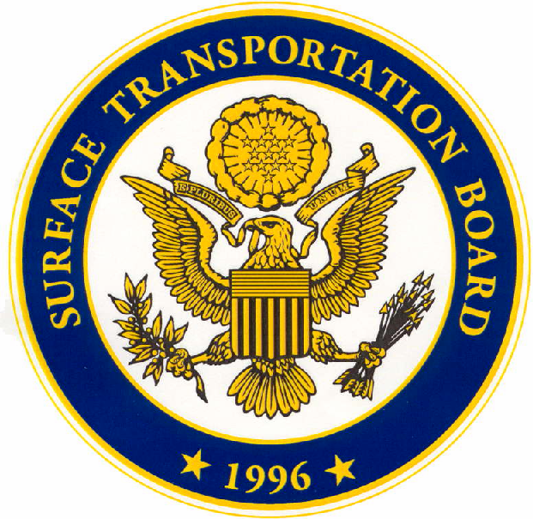

BEFORE THE

U.S. HOUSE OF REPRESENTATIVES
COMMITTEE ON TRANSPORTATION AND INFRASTRUCTURE

SUBCOMMITTEE ON RAILROADS, PIPELINES,
AND HAZARDOUS MATERIALS

AT A HEARING REGARDING

INVESTMENT IN THE RAIL INDUSTRY

March 5, 2008
11:00 A.M.
Room 2167 Rayburn House Office Building

Testimony of Charles D. Nottingham
Chairman of the Surface Transportation Board
Before the Committee on Transportation and Infrastructure
Subcommittee on Railroads, Pipelines, and Hazardous Materials
Hearing on Investment in the Rail Industry
11:00 a.m. March 5, 2008
2167 Rayburn House Office Building

Good morning Chairwoman Brown, Ranking Member Shuster, and Members of the Subcommittee. My name is Charles D. Nottingham, and I am Chairman of the Surface Transportation Board (Board or STB). I appreciate the opportunity to appear before this Subcommittee today to discuss investment in the rail industry, an issue that is vitally important to the freight railroads, their customers and employees, and the Nation’s freight transportation system as a whole.
When Congress passed the Staggers Act in 1980, the Nation’s rail system was in desperate financial straits. It was burdened with excess capacity and unproductive assets, forced to provide unprofitable services, and hampered by excessive government regulation. It was not an industry into which many investors wanted to put their dollars.
Since 1980, regulation has been reduced, carriers have been permitted to abandon unprofitable lines, and the rail system has rationalized much of its excess capacity, particularly its lighter-density lines. In recent years, however, the U.S. economy has expanded, and the rail network, like other transportation sectors, has become capacity-constrained. Unlike some other transportation sectors – trucking companies, for example, which can buy new equipment or hire more drivers – railroads cannot respond as readily to capacity constraints by quickly building new track and other facilities. Not only are rail construction projects expensive and time-consuming, but these projects can generate significant opposition on environmental and community-impact grounds.
Nevertheless, as shown by the following charts, it appears that railroads are increasing their investments in road, plant, and equipment at a rate that is consistent with the financial market evaluation of railroad future growth prospects:

Between 2004 and 2007, the market capitalization of the large railroads (reflecting end-of-year stock values) has increased by 24.1 percent annually in real terms, which indicates that the market expects railroad earnings to continue to be stable or to grow. At the same time, capital investment has increased annually by 21.6 percent, again in real terms. Thus, it appears that railroads are making investments to the extent that they believe that those investments will pay off in the market.
Consistent with the growth in stock prices, railroads recently have also attracted renewed interest from the financial community, which apparently views the railroads’ future as relatively bright in light of the recent increase in traffic and anticipated future traffic levels. Indeed, since late 2006, several investment funds, including Berkshire Hathaway, have acquired substantial positions in several Class I railroads.
While some have expressed concern with recent international investment in railroads, such financial markets have historically contributed to the financing of U.S. railroads, and international investors remain active today in the numerous U.S. industries that are a part of the global marketplace. However, concerns have surfaced regarding investors who have not traditionally invested heavily in railroads, such as hedge funds and certain large institutional investors, some of which are international. This new investor interest in the rail industry carries with it the possibility of a takeover of a railroad by a non-railroad entity. The STB has received numerous inquiries about how we would respond to such a transaction.
The “merger and acquisition” provisions of the Interstate Commerce Act provide that when two or more rail carriers seek to consolidate through a merger or common control arrangement, or when a noncarrier buys multiple carriers, prior approval of the Board must be obtained. Also, the “line sale” provisions of the Act require noncarriers to obtain Board authority before they can build or buy a particular rail line. Non-railroad investors, however, do not typically buy individual rail lines; they buy stock in a carrier or carrier system.
When a noncarrier buys a controlling interest in the stock of a holding company that owns several unrelated rail carriers, it must obtain STB authority, as Fortress Investment Group did when it obtained control of the RailAmerica family of small railroads in 2007. Were a noncarrier to acquire a controlling interest in the stock of a single railroad or a single integrated rail system, I do not believe that regulatory approval would be required under the statute.
The question of the agency’s jurisdiction over takeovers involving a single rail system arose in 1989 with respect to a proposed takeover of Chicago and Northwestern Transportation Company by Japonica Partners. In response to a request from the Senate Commerce Committee, the ICC prepared a report in which it analyzed the relevant statutory provisions and concluded that it would be difficult for the ICC to exercise jurisdiction over the proposed transaction. Reacting to the ICC’s report, Congress quickly moved to give the agency responsibility for approving such transactions. In particular, legislation that would have required ICC approval for a noncarrier to acquire direct or indirect control over a Class I rail carrier was approved by Congress in 1989. President George Herbert Walker Bush, however, vetoed the legislation, citing the “unprecedented new regulatory review requirement” that the new legislation would have imposed on the ICC. Although not dispositive, this legislative history tends to confirm that, under the existing statute and agency precedent, the agency lacks authority to approve the acquisition of a single rail system by a noncarrier.
I do not believe that the statute needs to be changed to give the Board more extensive review authority. The Board’s governing statute specifically gives the Board authority to inspect carrier records and to “inquire into and report on the management of the business of carriers providing transportation and services subject to [the Board’s jurisdiction].” Moreover, under the Rail Transportation Policy of 49 U.S.C. 10101, the Board, in regulating the rail industry, is to take into account, among other things, the need to “ensure the development and continuation of a sound rail transportation system,” to “foster sound economic conditions in transportation,” and to “encourage honest and efficient management of railroads.” Because the acquisition of voting control of a single rail system could affect the management of the acquired firm, the Board could inquire into and report on it under 49 U.S.C. 721, much as the ICC did with the proposed takeover of Chicago and North Western Transportation Company by Japonica Partners in 1989.
More importantly, any owner – even a current rail owner – has the capability of over-leveraging its firm’s assets, neglecting to maintain its capital infrastructure, or degrading service. Regardless of ownership, I believe that the Board has sufficient tools already to ensure that carriers, regardless of their ownership status, carry out their common carrier obligation as railroads. Were the Board to look into the management of a carrier and find that the carrier’s owners were stripping its assets so that the carrier could not carry out its common carrier obligation, the Board or the Department of Justice could take enforcement action to compel the carrier to comply with the statute and with STB orders. The Board could also, on complaint, find that the carrier violated the statute and award damages.
I understand the concern that a dominant investor with a very short-term focus could harm the long-term prospects of a particular company as well as disrupt interstate commerce if a policy of diverting revenues, neglecting shippers, and cutting back on capital spending were to be implemented. A railroad controlled by a large non-railroad investor, however, is still bound by the same obligations of all railroads: it must fulfill the common carrier obligation; it must maintain reasonable rates and practices; and it must file for abandonment or discontinuance authority if it is not going to provide service over a line. Given the Board’s ability to address concerns that may arise in the future, I would not recommend doing anything at this time to deter needed investment in the industry.
Given the magnitude of rail infrastructure needs and the lack of alternative sources of funding, Congress and the STB should be very careful to avoid sending signals to the financial markets that we do not welcome and encourage investment in the privately owned rail system. Freight railroads in the U.S. are in reasonably good financial shape and are attracting investors of all types and sizes. The rail industry’s ability in future years to continue this trend will largely determine whether the rail sector will have the resources needed to meet growing demand for rail service. The Board will remain vigilant and proactive to ensure that interstate commerce is not harmed by a short-sighted effort to extract large profits while neglecting the infrastructure and rail customers.
I appreciate the opportunity to discuss these issues today, and look forward to any questions you might have.

Capital expenditure data are from BNSF, UP, CSX, NSC, and KCS financial reports filed with the SEC. Market capitalization data are from BNSF, UP, CSX, and NSC and reflect end-of-year market value of stock outstanding. Nominal values are adjusted by the GDP deflator.
See 49 U.S.C. 11323.
See 49 U.S.C. 10901.
President's Message to the House of Representatives Returning Without Approval the Amtrak Reauthorization and Improvement Act of 1990, 1 Pub. Papers 718 (May 24, 1990).
49 U.S.C. 721(b)(1).
49 U.S.C. 10101 (4), (5), and (9).

